ASSIGNMENT 5

1. C++ Program to Store Information of a Student in a Structure

PROGRAM:

#include <iostream>

using namespace std;

struct student

{

char name[50];

int roll;

float marks;

};

int main()

{

student s;

cout << "Enter information," << endl;

cout << "Enter name: ";

cin >> s.name;

cout << "Enter roll number: ";

cin >> s.roll;

cout << "Enter marks: ";

cin >> s.marks;

cout << "\nDisplaying Information," << endl;

cout << "Name: " << s.name << endl;

cout << "Roll: " << s.roll << endl;

cout << "Marks: " << s.marks << endl;

return 0;

}

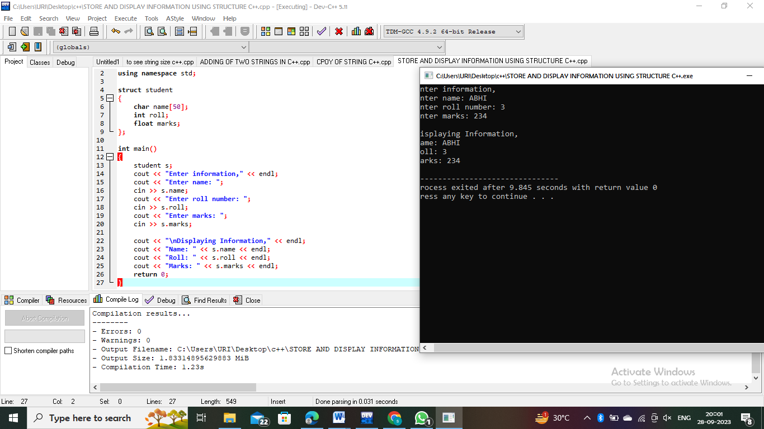

2. C++ Program to Calculate Difference Between Two Time Period

PROGRAM:

#include <iostream>

using namespace std;

struct TIME

{

int seconds;

int minutes;

int hours;

};

void computeTimeDifference(struct TIME, struct TIME, struct TIME \*);

int main()

{

struct TIME t1, t2, difference;

cout << "Enter start time." << endl;

cout << "Enter hours, minutes and seconds respectively: ";

cin >> t1.hours >> t1.minutes >> t1.seconds;

cout << "Enter stop time." << endl;

cout << "Enter hours, minutes and seconds respectively: ";

cin >> t2.hours >> t2.minutes >> t2.seconds;

computeTimeDifference(t1, t2, &difference);

cout << endl << "TIME DIFFERENCE: " << t1.hours << ":" << t1.minutes << ":" << t1.seconds;

cout << " - " << t2.hours << ":" << t2.minutes << ":" << t2.seconds;

cout << " = " << difference.hours << ":" << difference.minutes << ":" << difference.seconds;

return 0;

}

void computeTimeDifference(struct TIME t1, struct TIME t2, struct TIME \*difference){

if(t2.seconds > t1.seconds)

{

--t1.minutes;

t1.seconds += 60;

}

difference->seconds = t1.seconds - t2.seconds;

if(t2.minutes > t1.minutes)

{

--t1.hours;

t1.minutes += 60;

}

difference->minutes = t1.minutes-t2.minutes;

difference->hours = t1.hours-t2.hours;

}

